Project Title: Supporting Rule of Law for Peaceful and Inclusive Societies in Pakistan (Amn-o-Insaf)
Project Number: TBD
Implementing Partner: UNDP Pakistan
Start Date: 1 July 2019 End Date: 30 June 2023 PAC Meeting date:

Brief Description
Marked by internal and external challenges related to conflict, extremism, weak democratic structures, lack of accountability and transparency, Pakistan is currently undergoing a major transition and continues to experience historic developments in political, governance and development realms. The Global Rule of Law Index for 113 countries ranks Pakistan at 105 for overall rule of law situation and 80 on criminal justice system. The access to formal justice system remains difficult as an estimated 1,9 million cases have been pending in the superior and subordinate courts in Pakistan. Recognizing these challenges, UNDP aims to facilitate a convergence between people’s expectations for a just and secure society and the institutional capacities necessary to deliver essential services. To do so, the UNDP’s Global Programme on Strengthening the Rule of Law and Human Rights for Sustaining Peace and Fostering Development launched a dedicated initiative on Rule of Law and the 2030 Agenda in 2017. The initiative focuses on supporting the rule of law, human rights, and security as accelerators for achieving the SDGs. In Pakistan, the initiative is undertaken through this Amn-o-Insaf Programme.
Contributing Outcome (UNDAF/CPD, RPD or GPD): CPD Outcome 9: By 2022, the people in Pakistan, especially the most vulnerable and marginalized, have increased knowledge of their rights and improved access to more accountable, transparent and effective governance mechanisms and rule of law institutions.
UNSDF Outcome: Indicator: UNSDF 9.2: Government effectiveness, and rule of law as measured by World Bank’s ‘Worldwide Governance Indicators’
UNDP Strategic Plan Output 2.2.3: Capacities, functions and financing of rule of law and national human rights institutions and systems strengthened to expand access to justice and combat discrimination, with a focus on women and other marginalized groups:
Country Programme Output: Strengthened functioning, financing and institutional capacities facilitate access to justice and improve redress mechanisms by the rule of law institutions.

Indicative Output(s):
Output 1: Policy, legal and regulatory framework strengthened to ensure affordable, equitable, timely and accessible delivery of justice
Output 2: Increased access to justice through formal and informal justice mechanisms particularly for women, minorities, juveniles and disabled people.
Output 3: Justice and security services delivery improved in line with constitutional safeguards and international standards.
Total resources required: | USD 70,075,200
Total resources allocated: | USD
 | UNDP TRAC: | USD
 | Donor 1: | USD
 | Donor 2: | USD
 | Government: | USD
 | In-Kind:
Unfunded: | USD
Agreed by (signatures):
Government | UNDP
Print Name: | Print Name:
Date: | Date:

DEVELOPMENT CHALLENGE

Global Perspective

The rule of law lies at the center of the relationship between society and the state. Lack of respect for human rights fuels instability and undermines sustainable development. Measures to strengthen the rule of law and human rights are the basis for creating accountability among people as well as between citizens and their governments. Strengthening the rule of law and promoting human rights are cornerstones of UNDP’s work to achieve sustainable human development and eradicate extreme poverty. Through rule of law and human rights assistance, UNDP contributes to building peace and democratic governance across the full range of development contexts. Utilizing a rights-based development approach, UNDP supports Member States to foster a rule of law culture in which people experience greater peace and security and can exercise their rights, advance their livelihoods, and protect those of future generations.

The 2030 Agenda for Sustainable Development features for the first time a universally agreed goal for achieving peaceful, just and inclusive societies: Sustainable Development Goal (SDG) 16. There is increasing recognition that strengthening national capacities to uphold human rights and the rule of law is not only an outcome of SDG 16 but also an enabler and an accelerator of progress across the 2030 Agenda. The 2017 UN Sustainable Development Goals Report provides a mixed picture on progress against indicators related to the rule of law:
- Over the last 10 years, the rates of pretrial detention have only been reduced by 1%.
- While homicide rates have reduced globally over the past decade, they have increased in some regions, namely Latin America, sub-Saharan Africa, and Asia.
- 19% of women from 87 countries (between 15–49 years of age) have experienced physical and/or sexual violence by an intimate partner in the past 12 months according to surveys undertaken from 2005-2016.
- Half of all women who were victims of intentional homicide worldwide were killed by an intimate partner or family member, compared to 6% of males.
- By the end of 2016, 57% of countries had a national human rights institution (NHRI) that had been reviewed for compliance with internationally agreed standards (The Global Alliance of National Human Rights Institutions (GANHRI) by their peers and 37% of countries were found to be compliant.
Recognizing these challenges, UNDP aims to facilitate a convergence between people’s expectations for a just and secure society and the institutional capacities necessary to deliver essential services. To do so, the UNDP’s Global Programme on Strengthening the Rule of Law and Human Rights for Sustaining Peace and Fostering Development launched a dedicated initiative on Rule of Law and the 2030 Agenda in 2017. The initiative focuses on supporting the rule of law, human rights, and security as accelerators for achieving the SDGs.

Country Context

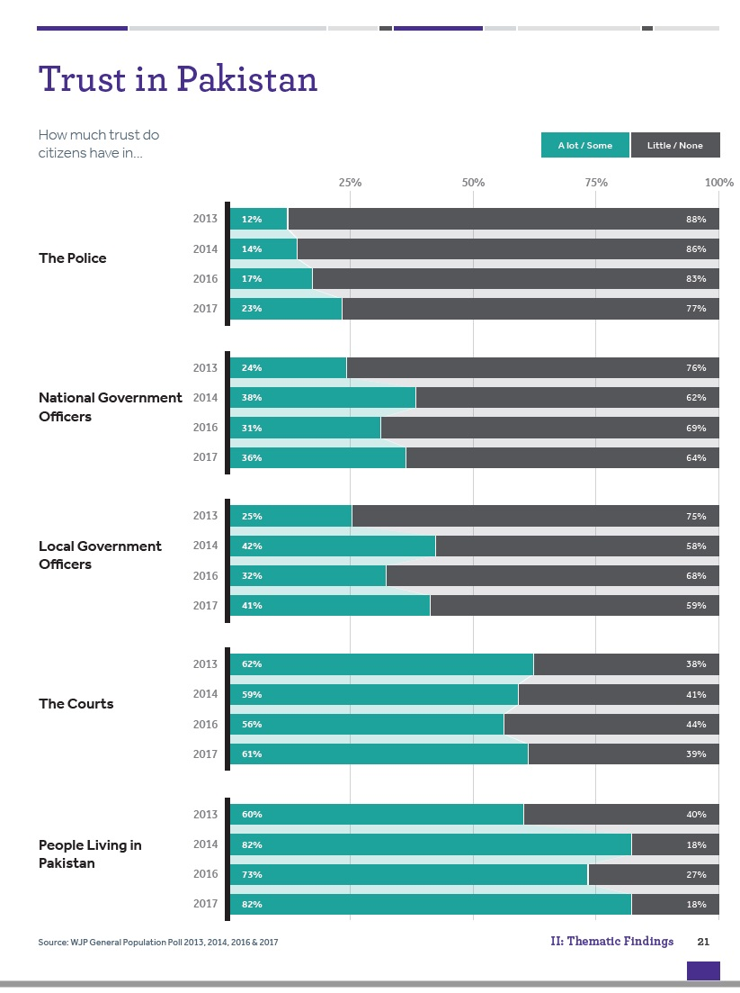
Marked by internal and external challenges related to conflict, extremism, weak democratic structures, lack of accountability and transparency, Pakistan is currently undergoing a major transition and continues to experience historic developments in political, governance and development realms. The Global Rule of Law Index for 113 countries ranks Pakistan at 105 for overall rule of law situation and 80 on criminal justice system.
The access to formal justice system remains difficult as an estimated 1,9 million cases have been pending in the superior and subordinate courts in Pakistan as of 2018. Among these cases 38,539 are pending in the Supreme Court, 147, 542 in the Lahore High Court, 93,335 with the Sindh High Court, 30,764 with the Peshawar High Court, 6,030 in the Balochistan High Court and 16,278 in the Islamabad High Court.

Likewise, the pendency of the district judiciary of Punjab is 1,184,551, Sindh 97,673, Khyber Pakhtunkhwa 204,030, Balochistan 12,826 and Islamabad 37,753. Also, very few people have access to justice through the state-sponsored legal aid system. Despite the overall complex scenarios, significant progress was made both at national and provincial levels to improve governance mechanisms contributing to the improvement in Pakistan ranking in the rule of law index for 2018. Pakistanis have a high degree of trust in fellow citizens, with 82% reporting that they have a lot or some trust in other people living in Pakistan. Across institutions, Pakistanis have the most trust in the courts (61%) and the least trust in the police (23%). Since 2013, the percentage of people who report having some or a lot of trust in the police has steadily risen from 12% to 23%.
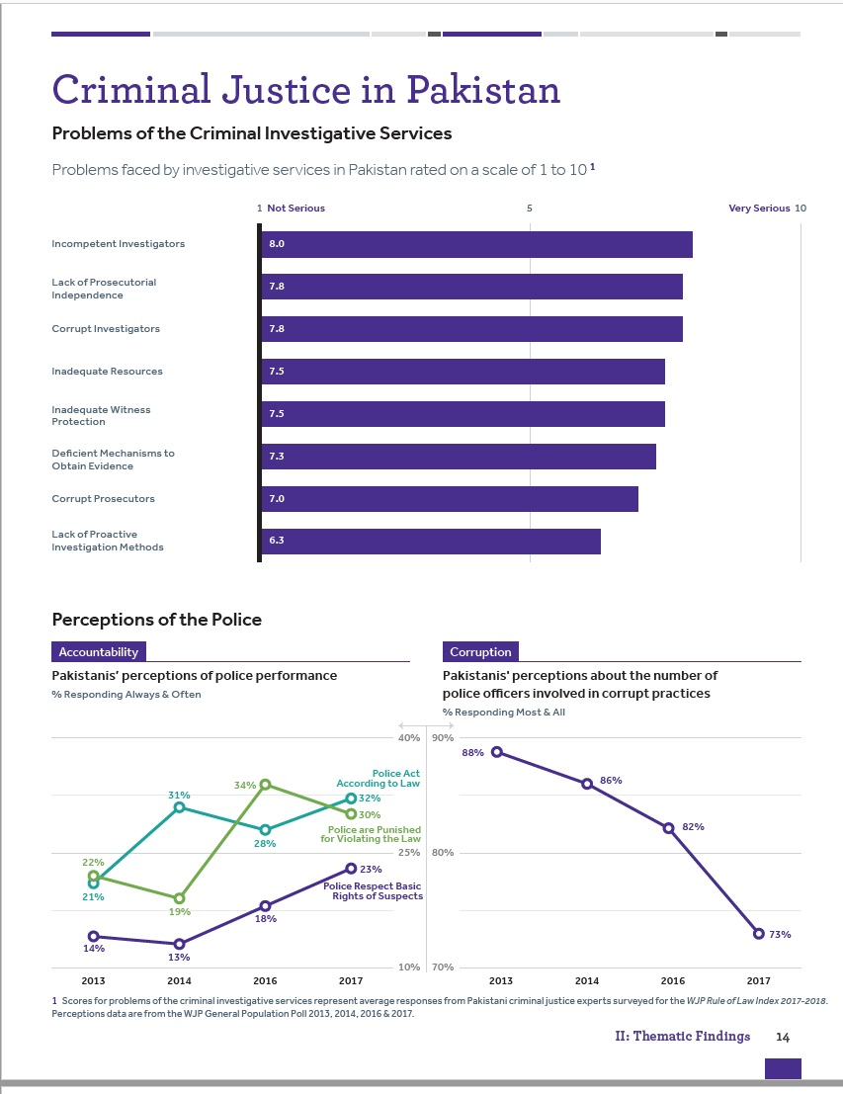
In place of a uniform national rule of law sector, Pakistan hosts a diverse number of criminal justice systems. They range from informal dispute resolution using customary practices to formal adjudication based on common law principles. While informal justice mechanisms do not meet the legal and human rights standards of justice, they are often claimed to have an important function to fill, particularly in civil and family law-related cases, where linkages between the formal and informal systems are weak. Therefore, the risk is that crimes such as gender-based violence, may be inadequately or inappropriately addressed by informal justice systems. While there has been some progress in recent years, including the introduction of police reforms, the availability, affordability and accessibility to formal quality justice services remains elusive. Political influence, corruption, and i incompetence of criminal investigators is the most serious problem facing criminal investigative services in Pakistan. Regarding police conduct, 32% of people believe that police always or often act according to the law, and 30% believe that police are always or often punished for violating the law. While these views have fluctuated since 2013, perceptions of police corruption and respect for suspects’ rights have improved in recent years. When it comes to criminal courts, inadequate resources were cited as their most serious problem. Views on how often courts guarantee everyone a fair trial and perceptions of corruption have both fluctuated since 2013. 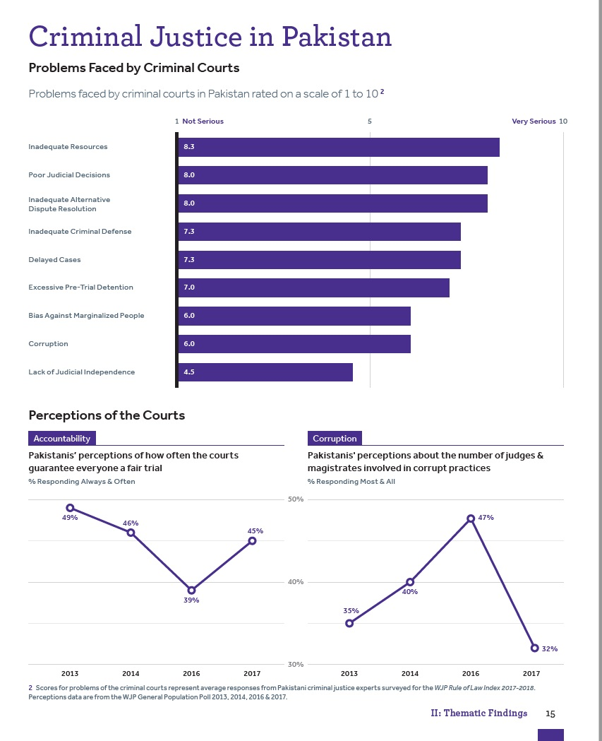

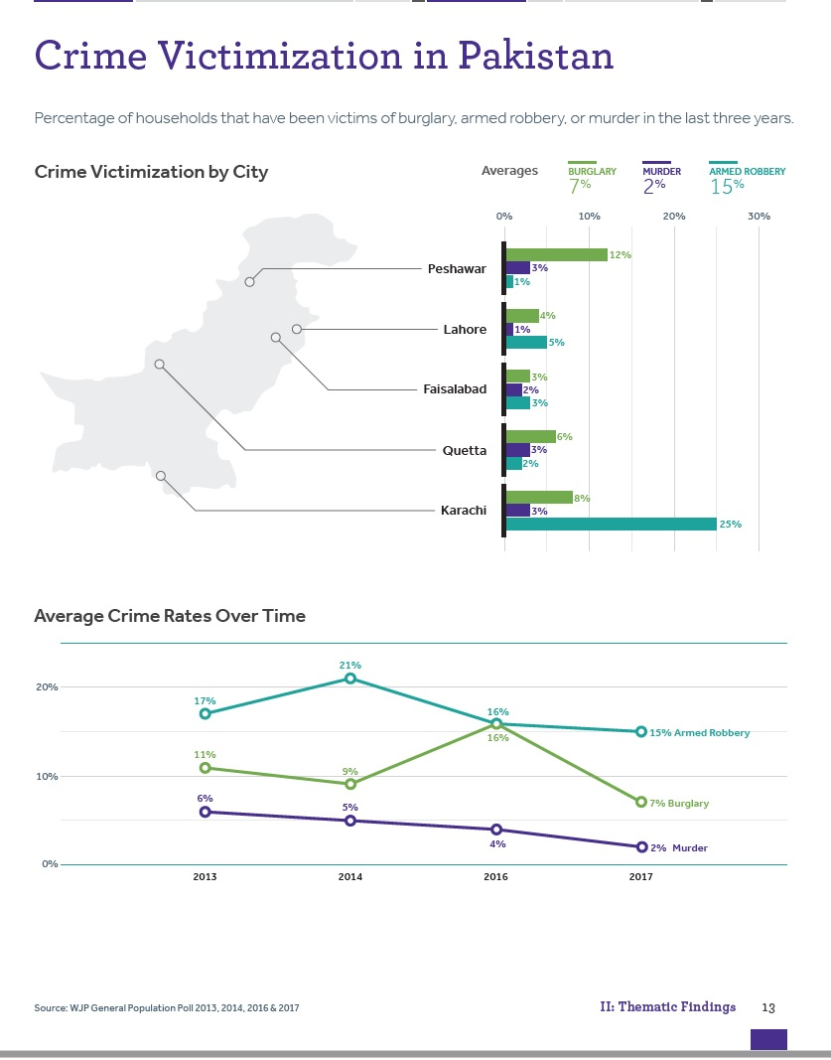
Crime rates in Pakistan vary by type of crime and city. On average, 7% of people reported that their household experienced a burglary in the last three years, 2% of households experienced a murder, and 15% experienced an armed robbery. Rates of armed robbery are the highest in Karachi (25%), burglary rates are the highest in Peshawar (12%), and murder rates vary between 1% and 3% across all five cities. On average, there has been a decrease in the rates of all three crimes since 2016.

The array of rule of law institutions and their relative capacities are well illustrated when comparing provinces including NMDs of Khyber Pakhtunkhwa as the constitutional justice system is yet to evolve there.

Khyber Pakhtunkhwa. Weak governance, political instability, terrorism, sectarian violence and conflicting legal systems have contributed to a fragile and ill-equipped rule of law sector in Khyber Pakhtunkhwa. Since 2011, Khyber Pakhtunkhwa has used most of its resources in its criminal justice system to address terrorism and insurgencies. The capacity of the rule of law institutions (police, prosecution, judiciary and prisons) remains low and unable to cope with the increasing number of reported crimes (180830) in the province. Towards the effort of increasing access to justice, Khyber Pakhtunkhwa has turned to alternative dispute resolution mechanisms: court-annexed ADR and Dispute Resolution Councils (DRCs) seated with the Police. The relationship between the ADR mechanisms, their scope in terms of subject matter jurisdiction and monitoring of results are not well understood by the institutions themselves or the general public. Moreover, while the police have been politically independent from the Home Department since 2002, the levies which are woefully under-resourced, remain in force where the police are not present and in the case of Malakand District are under the Deputy Commissioner who is appointed by the Home Department. Despite efforts to increase the public’s access to justice, the Khyber Pakhtunkhwa rule of law sector remains complex, layered, opaque, and lacks human rights standards. Khyber Pakhtunkhwa has adopted its comprehensive sector-wide Rule of Law Roadmap in May 2018.
Newly Merged Districts of Khyber Pakhtunkhwa. The marginalization and sustained inequality are attributed to the past constitutional arrangements which excluded the tribal area from mainstream Pakistan. All civil and criminal cases were dealt under the recently abolished Frontier Crimes Regulation 1901 (FCR) through a jirga (council of elders). Human rights safeguards enshrined in national and provincial laws and the Constitution were not available to its residents until recent 25th Amendment to the Constitution. Law enforcement is the responsibility of the Frontier Corps (a paramilitary force) and to some extent levies and khassadars (tribal militia). The civil police have no jurisdiction so far. Courts are similarly absent and jirgas appointed by Political Agents the chief administrator at the agency level who are recently designated as Deputy Commissioners and maliks (tribal elders co-opted by the government) hear and decide cases. The 25th Constitutional Amendment 2018 has extended the jurisdiction of the Supreme Court and Peshawar High Court and abolished FRC, merged FATA with the Khyber Pakhtunkhwa Province. Recently another milestone was achieved when Home Department Khyber Pakhtunkhwa issued a notification, declaring NMDs as Sessions Divisions leveling ground for the extension of district judiciary to the area. Also, the Chief Minister Khyber Pakhtunkhwa has approved summary for the recruitment of judges for the NMDs.
Balochistan has been adversely affected by terrorism and related violence. The terrorist insurgency gained strength from the deterioration of law and order in Afghanistan and overall political instability. The Police and Levies are responsible for maintaining law and order in the province. The Levies operate within the ‘B’ area of the province that constitutes 90% of the territory including all border areas and the Police are responsible for law enforcement in area ‘A’ (the rest 10% of territory) mainly in urban settlements (45% of total population). The Police operate under the Balochistan Act 2011, which the provincial government introduced after repealing the Police Order 2002. However, the Police Rules 1934, which are still in force are based on rules from 1861. The traditional Alternative Dispute Resolution (ADR) mechanisms have historically existed in the province and various ethnic groups living in the province rely on a mixture of customary law and sharia for the resolution of disputes. The Balochistan Local Government Act 2010 provides room for establishing ADR forums based within the elected local bodies, however, the local government department due to lack of technical capacity and financial resources has neither developed rules for such forums nor notified them. In 2018, Balochistan Government has adopted its Rule of Law Roadmap which provides a strategic vision for strengthening rule of law and justice services in the province.
Punjab, the largest populated province has the highest case backlog with 1,334,709 cases pending in courts. With more than 180,000 personnel (3000 women) the Punjab police constitutes the largest police force in the country. The Province Forensics Science Laboratory (PFSA) is the largest and well-equipped, most renown crime laboratory in Pakistan. Since establishment of the PFSA, it has received 458049 cases for analysis under various disciplines. The province has passed the Punjab Legal Aid Act, 2018 which provides for establishment of a Legal Aid Agency to deliver legal aid to disadvantaged persons and maintain panel of legal aid lawyers. Under the Punjab ADR Act 2017, the Judiciary has established ADR centers in almost every district of the province for providing Court-Annexed ADR services to the masses. The Punjab Local Government Act 2013 allows the Local Government to establish Panchayat and Muslihat Anjuman for resolution of disputes at the local level however like other provinces, the ADR forums under Local Government remain ineffective. Punjab was the first province to adopt Rule of Law Road map in Pakistan, however, the provincial judiciary was not involved in the process that requires further improvement.
In Sindh, the security and law and order remain volatile, particularly in Karachi metropolitan area. The Sindh Police is struggling to ensure law & order assisted by Pakistan Rangers (a para military force) who were given extensive powers including policing. Several large scale intense military operations were conducted to diminish the terror groups, gangs and armed wings of some political parties. However, due to lack of dedicated, long-term and comprehensive rule of law and security plan, most of the time the situation remained unstable and volatile with small peaceful and silent intervals. Interior Sindh particularly affected by inter-tribal conflicts and related criminalization. The judicial system of the province is overwhelmed with case delays and backlog. In 2018, the province has backlog of 193,224 cases which will need comprehensive reformation. The Government has developed a Rule of Law Roadmap to provide a strategic roadmap to strengthen rule of law in the province. For expeditious resolution of disputes, the Sindh Assembly has recently passed the ADR Bill 2019 which strengthens court-annexed ADR and provides room for out of court settlement of disputes at any stage of the case.
Gilgit Baltistan (G.B) and Pakistani administered Azad Jammu & Kashmir (AJK). GB & AJK were parts of the former Princely State of Jammu & Kashmir which came under administration of Pakistan in 1947-48. The region is recognized as disputed territory according to UNSC resolutions. The United Nations Commission for India & Pakistan (UNCIP) resolution 1949, calls on the Government of Pakistan to establish empowered local authorities in GB and AJK. GB & AJK are not constitutional parts of Pakistan and don’t enjoy representation in the Parliament or Judiciary. The Government of Pakistan has established local governance and justice structures in GB & AJK, but they are neither empowered nor do they have decision making authority. The Government of Pakistan constituted a committee to seek recommendations for improving the governance and justice sectors in GB, the committee in its report 2018, recommended to empower the local governance structure, enhance representation mechanism and to introduce institutional reforms in GB. In AJK, the slow criminal justice system, weak rule of law, parallel system, silo mentality in government departments, weak regulatory framework, absence of uniform and standardized basic police legal framework, ill-integration between formal and informal judicial systems, absence of use of modern technology and case management in courts.

Sectoral reforms aimed at enhancing access to justice, reforming the criminal justice sector and empowering the local authorities are needed to safeguard the rights of local communities and to strengthen the rule of law.

All provinces cope with a general lack of consistent and formal training programs for personnel working within the rule of law institutions. New recruits, and those with experience, rarely receive substantive training, and there is very little opportunity to benefit from advanced training such as the application and use of forensic evidence in court. As such, across all provinces, there is a critical need to provide uniform basic and advanced training to all personnel working in the respective rule of law sectors.

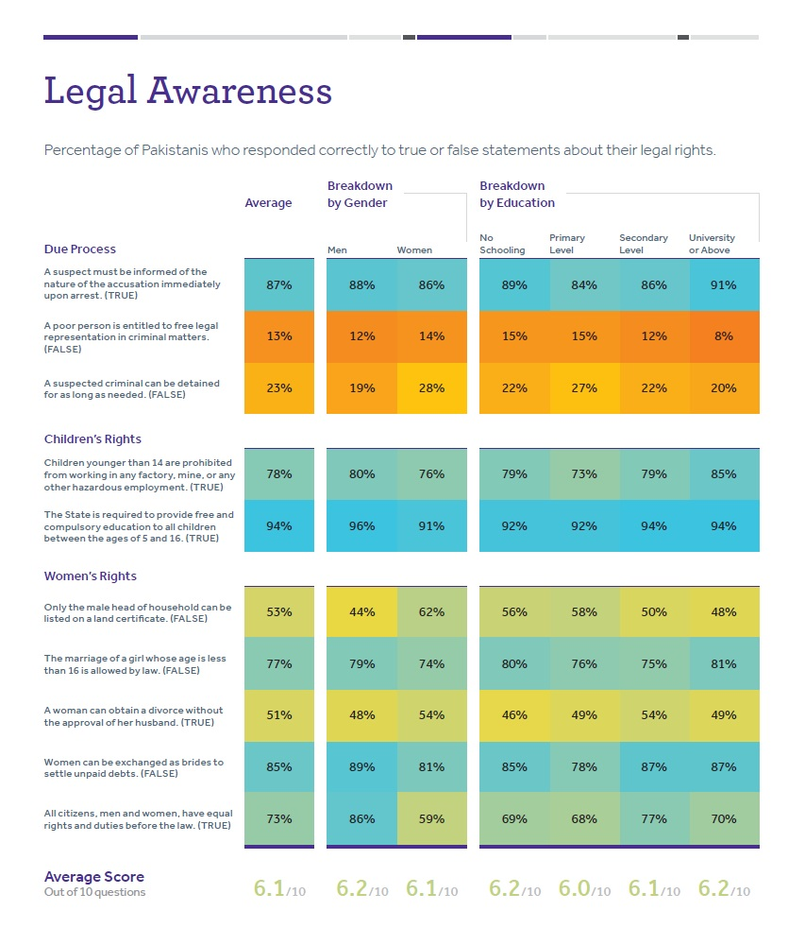
Pakistan people in general lack legal knowledge, particularly about due process and related rights. Neither gender nor higher levels of educational attainment correlated with better legal knowledge. To properly address issue of violence against women (VAWG) and increase access to justice for women requires the combined efforts of the entire justice chain. In all provinces, access to justice for women is particularly challenging due to long-held cultural traditions and attitudes towards VAWG. The limited capacity of police and prosecutors to investigate and prosecute crimes against women and girls, and biases held judges discourages women from reporting crimes. Few police stations have the facilities to appropriately address the needs of survivors of violence or have personnel who have had gender-responsive training. The awareness of police on legislation is limited while simultaneously the public also remains largely ignorant of their rights. In addition, provisions of the Penal Codes at the federal and provincial levels on rape, adultery, sexual violence committed in marriage (not a crime in Pakistan) and “honor killings” display clear discrimination against women. For example, the legal system allows for reduced sentences for people convicted of murdering women to “protect” family honor and the disputed Hudud ordinances are still in place despite revisions in 2012. Women make up 0.94% of the total police force in Pakistan, among the lowest in the SAARC region in spite of nationwide quotas set at 10%. Khyber Pakhtunkhwa and Balochistan are trailing further behind with 0.72 and 0.31 percent respectively.
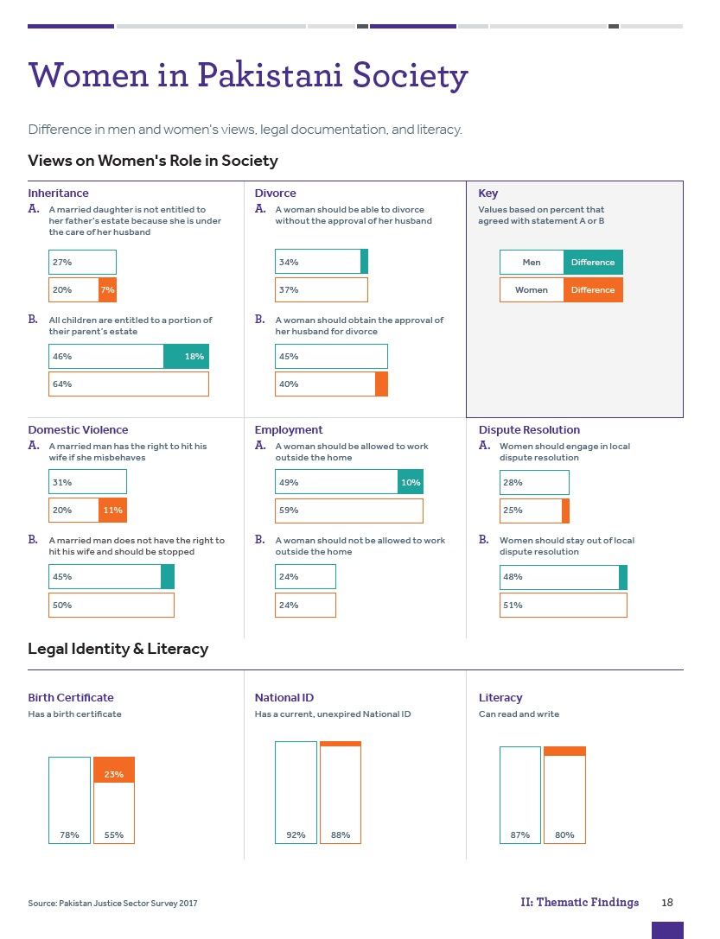

The Government of Pakistan has taken and will continue to take steps to ensure that rights of its citizens are protected and safeguarded in line with its constitutional and international obligations. Landmark initiatives include inter alia the development of the NISP, the NAP and the provincial rule of law roadmaps and allocation of resources for the implementation. The National Action Plan 2014 (agenda point 20) stresses revamping and reforming of criminal justice system. Also, the priorities set for “Aman-o-Insaf Programme”, are directly co-related to the priorities of the current federal government; a) reforming police service by following the tracks of Khyber Pakhtunkhwa Police, b) reforming of the justice services; and c) protection of women’s rights and lawful entitlement particularly their right to inheritance in Pakistan. Point 11 of the agenda focuses on women particularly on their education, and protection of women entitlements and particularly right to inheritance.

STRATEGY
Supporting rule of law for peaceful and inclusive societies in Pakistan will be the ultimate objective of the “Amn-o-Insaf” Programme. UNDP global Strategic Plan 2018 -2022 sets a signature solution to achieve this objective: strengthen effective, inclusive and accountable governance. Inclusive and accountable governance systems and processes are recognized as crucial to sustainable development and human security. This solutions package will, therefore, focus on supporting diverse pathways towards peaceful, just and inclusive societies, building on the UNDP comparative advantage and long track record in governance. Some development contexts may require support for core governance functions, establishing local service provision, rule of law, anti-corruption capacities and access to justice. Others may request innovative support for improved regulatory capacities, enhanced legal frameworks, strengthened institutions and local governance capacities. This solution will seek to build inclusive, effective and accountable institutions and mechanisms for the peaceful resolution of conflict and for advancing social cohesion. This requires ensuring the inclusion of women, youth, people with disabilities and other traditionally marginalized groups. This signature solution will be delivered in partnership with other United Nations agencies, in line with comparative advantage and operational capacities and in response to government requests.
Aligned with UNDP’s five-year Pakistan Country Programme Document 2018-2022 (Outcome 1 (UNSDF Outcome 9), the Programme’s overall strategy will be based on three key aspects:
- Comprehensiveness,
- Coordination; and
- Continuance.
Programmatic comprehensiveness will be pursued via a ‘top-down and bottom-up’ approach with a deliberate focus on ensuring women’s inclusion. The Programme will focus on a widely accepted approach: the need for ‘bottom-up’ programming that empowers society (claim holders) and brings it closer to the state (duty holders), combined with a ‘top-down’ engagement for “institutional transformation” in the priority areas of justice and security. Such an approach enables both the ‘supply’ and ‘demand’ components of the justice equation to be met. The Programme emphasizes the need for grassroots approaches to strengthen state-society relations as the restoration of public confidence cannot happen unilaterally by the state (i.e. top-down alone). Further, this kind of inclusive engagement is needed to increase local ownership of interventions, and thereby, sustainability.

The Programme will apply gender responsiveness as a key component of its ‘top-down, bottom-up’ approach to ensuring inclusivity. The Programme will monitor the depth of its intervention for inclusivity by how effectively it will reach the most vulnerable demographics of claim holders, particularly women and gender non-conforming populations. Implementation will incorporate analysis of the gendered impact of policy development and service delivery, ensure inclusion of female participation and stake-holders in outreach and dialogue measures as well as within rule of law institutions.

Coordination is primarily understood as the need to ensure alignment with national strategy, policy and planning. The Programme intends to ensure larger scale coordination as well by its level of engagement. Namely, the Programme will adopt a national-wide approach to interventions that requires a broader engagement than at provincial level alone to be effective and relevant; therefore, the Programme will establish strong linkages with the national level stakeholders, i.e. Economic Affairs Division, Ministry of Interior, Ministry of Law and Parliamentary Affairs, Inter-Provincial Coordination Ministry, Law and Justice Commission of Pakistan, National Police Bureau, Pakistan Bar Council, Supreme Court of Pakistan, National Commission for Human Rights, National Commission on Status of Women, Ombudspersons, and relevant Parliamentary Committees,. This is in addition to encompassing substantive coordination along the justice chain to ensure linkages are identified and leveraged for programming. Finally, beyond its core partnership with the Government and national stakeholders such as civil society actors, the Programme will ensure coordination both within the UNDP Country Office, the wider UN Country Team, with the donor community and other multilateral actors.

Finally, the Programme will encompass the continuance component of its strategy to ensure implementation is forward-looking in terms of securing sustainability of results. To this end, implementation will be governed by the following:

• ensuring national ownership of interventions;
• building not supplementing/replacing national capacities; and
• maintaining sufficient flexibility so as to remain responsive to context.

National ownership, at the core of all development principles, will be supported in several ways. One, through constant consultation with national partners including the government and civil society. Two, sustainability through rooting its actions in building, not substituting, national capacities via sustainable training and institutionalizing support in broader governmental structures and planning processes. Three, the Programme will ensure interventions have an enduring effect through linkage of activity level engagement with policy- and system-level change. To further support sustainability, the Programme states that incredible flexibility will be required in a fragile setting. Different mechanisms, such as the Programme Review Board meetings, are intended to be used to assess what is working and what is not, enabling a ‘scale up’ or ‘scale down’ to respond to on the ground realities.

Diagram 1: Amn-o-Insaf Programme Strategy
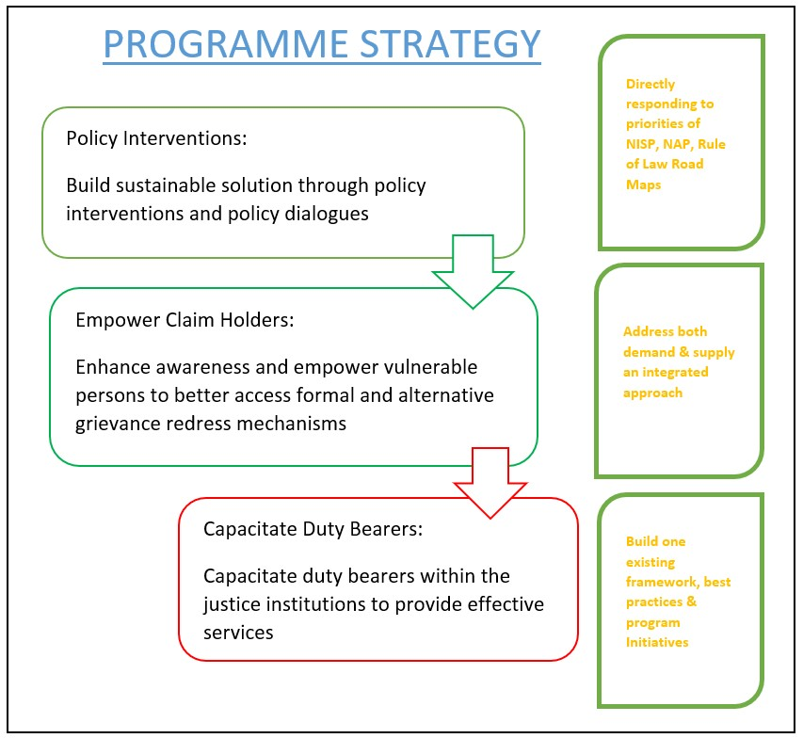

Importantly, the Programme would also contribute to UNDP vision to support implementation of the 2030 Agenda. It contributes primarily to the progressive achievement of SDG(s) 16 Peace, Justice and Strong Institutions, and 5 Gender Equality but also promotes progress towards Goal 10 Reduced Inequality. In particular the SDG 16.3 (Promote peaceful and inclusive societies for sustainable development, provide access to justice for all and build effective, accountable and inclusive institutions at all levels) and SDG 5.1 (End all forms of discrimination against all women and girls everywhere) will be addressed through enhanced access to justice for all, particularly women and marginalized groups.

Similarly, supporting reform processes to ensure delivery of people-centered justice addresses the SDG 16.6 (Develop effective, accountable and transparent institutions at all levels) as well as SDG 5.c (Adopt and strengthen sound policies and enforceable legislation for the promotion of gender equality and the empowerment of all women and girls at all levels).

Gender Mainstreaming:
Pakistan stands amongst the group of countries where gender inequality, systematic disempowerment and segregation of the women is a common issue and ranks at 148 on the Gender Equality Index of 149 countries. Pakistan has adopted several international commitments, i.e. Convention on the Elimination of all forms of Discrimination Against, Women Universal Declaration of Human Rights, Beijing Platform for Action, and Sustainable Development Goals. Domestically, Pakistan has also developed a legal framework, i.e. Protection against Harassment of Women at Workplace Act, Criminal Law (Amendment) (Offences Relating to Rape), Criminal Law (Amendment) (Offences in the name or pretext of Honour) Act, National Policy for Development and Empowerment of Women, National Plan of Action on Human Rights and initiatives like Gender Equality Policy Frameworks and Women’s Empowerment Packages. However, despite holding numerous international commitments and enabling national framework, Pakistan ranks one of the lowest in the world for gender equality.

The Programme will follow UNDP Global and Country specific policy on gender equality so that equal attention should be given to the visible and hidden factors. The Programme through UNDP CO will establish close coordination with the UN Agencies (UN Women, UNODC, UNHCR), national and international organizations, relevant government departments and institutions and UNDP projects focusing on human rights, gender equality, gender mainstreaming, and legal empowerment of women and transgender by providing access to the legal support services, legal awareness, support to the civil society, and engagement at all tiers of governance.

For the Programme gender will remain as a cross-cutting theme and will contribute to SDGs 5 (Gender Equality) and SDG 16 (Rule of Law). On Gender Equality (SDG 5) and Rule of Law and access to justice (SDG 16), the programme will closely coordinate with all SDGs Units and rule of law institutions to streamline reporting on SDG 5 and 16.

The Programme under its Phase I and II has achieved tangible results, including establishment of gender-enabling environment (women dormitories in training institutes), gender desks at MPS), support to institutions to raise number of women officers (development of gender strategy for the LEAs, women lawyers’ forum and its charter, legal empowerment of women through legal awareness. Based on these results, during Phase III, the Programme will focus on systemic approach on gender mainstreaming combining policy level work with piloting feasible innovative approaches.

Theory of Change
The Programme’s theory of change approach will articulate long-term goals, identify measurable indicators of success and formulate actions to achieve those goals. This will be centered on closing gaps in access to justice as identified through participatory processes and assessments, feeding this evidence upstream to inform national priorities for rule of law reform, including institutional, legal and policy frameworks. The Programme will focus on fewer entry points to be more strategic and allowing for a focus of resources to pursue moderate but important reforms and provision of services on the ground. It will develop realistic targets and outcomes based on what can be achieved. Hence the Programme’s actions will be designed in close co-operation with national partners allowing for a connection between the programme design and local context, adopting a flexible approach and built upon the trust already created, to seek realistic and achievable changes.

Theory of Change Statement:

IF… Increased participation and dialogue between people and civil society with the formal and informal justice system and law enforcement, promotes the rights-holders’ side through increased awareness by people about claiming their rights and accessing services;

AND
of the duty bearers’ side for state actors to be more responsive and service oriented on justice and security issues;

THEN It will further facilitate identification and design of solutions anchored in and owned by local communities, promoting oversight and demands for accountability by the population;

WHICH WILL promote a more equitable access to justice system;

AND ultimately contribute to increased public confidence and the creation of a virtuous circle for improved service delivery and administration of justice.

The Programme will address gaps in the rule of law and justice system reforms through four mechanisms:

- Improving Policy and Regulatory Framework for the Rule of Law, Justice, Security and Law Enforcement Agencies: The Programme will work closely with the Policy and Law Makers, Institutions and concerned institutions to improve laws, rules and regulations aiming to improve legal and policy framework for the supply side of the rule of law, justice, security and law enforcement institutions with objective to improve individual and institutional performance, efficiency in service delivery, internal and external accountability mechanism and transparency.

- Strengthening supply side of the Rule of Law, Justice, Security and Law Enforcement Agencies: The Programme will also work to strengthen demand side of the rule of law and justice system. Under this, the Programme will provide technical and institutional support to overcome the capacity issues of the individuals and institutions through designing and in placing a better training regime, well-equipped training institutions, and training of the personnel. The Programme will also provide technical support to the institutions to develop less expensive, efficient and public service-oriented models. The Programme will build upon SRLP experience in Khyber Pakhtunkhwa and Balochistan and UNDP’s experience globally.

- Strengthening Demand side of the Rule of Law and Justice system: The Programme will equally focus on strengthening the demand side of the rule of law and justice system. The Programme will work with the duty bearers and communities to improve access to justice for the poor and vulnerable segments including women, juveniles, aged, refugees, internally displaced persons and minorities. The Programme will build upon SRLP experience in Khyber Pakhtunkhwa, Balochistan and UNDP experience globally.

- The programme will promote fair and effective informal dispute resolution mechanisms including through community-based paralegals and statutory ADR system. Combined with support to free legal aid these interventions will provide avenues for improved access to justice for disadvantaged people, especially women and minorities.

The Programme will use UNDP’s strong partnership with the provincial and federal governments for strong ownership and cost sharing for better and sustainable results. The Programme Advisory Board comprising of senior experts in rule of law, justice, security and law enforcement will provide support to forge strong relationship with the Government and rule of law institutions. With the Advisory Board, risks and chances of harms will be substantially reduced and UNDP and Donors organizational prestige and respect will be safeguarded as well.

Gender and youth are cross-cutting issues of the programme. At all levels, situation and beneficiary analysis of all activities will be conducted based on gender and age-disaggregated data. This data will be used as a baseline to provide evidence for developing a gender and juvenile justice strategy.

All interventions will be guided by the following key principles: i) adherence to the “Do No Harm” principle; ii) Monitoring and Evaluation; iii) Ensuring clear linkages between the expected results of the interventions to Programme outputs and outcomes, and iv) Best value for money.

Diagram 2: Theory of Change
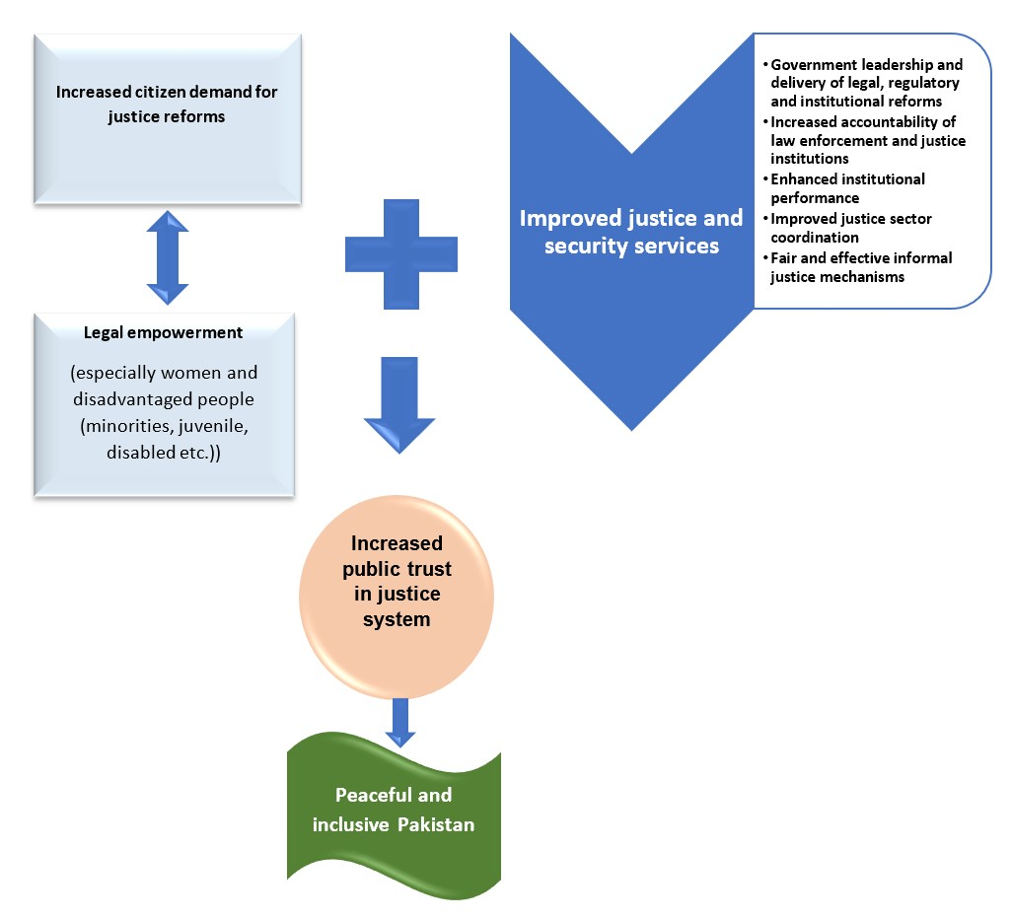

RESULTS AND PARTNERSHIP
Expected Results
The overall outcome of the Programme will increase public confidence and trust in justice system.
Programme Outputs
- Output 1: Policy, legal and regulatory framework strengthened to ensure affordable, equitable, timely and accessible delivery of justice
  - Policy and legislative reforms promoted for affordable and speedy justice services
  - Justice sector strategic planning, management, coordination and accountability mechanisms strengthened
Output 2:
- Increased access to justice through formal and informal justice mechanisms particularly for women, minorities, juveniles and disabled people.
  - Demand mobilized for reforms and enhanced legal literacy of citizens with special focus on women
  - Free legal aid made accessible especially for women and disadvantaged people
  - Legal representation improved especially for women and disadvantaged people
  - Alternative dispute resolution mechanisms are available and regularised with the focus on accessibility for women and disadvantaged people
- Output 3: Justice and security services delivery improved in line with constitutional safeguards and State ratified international human rights standards
  - Capacity and efficiency of justice sector institutions enhanced to ensure effective people-centered services
  - Women participation in legal profession increased
  - Accountability and oversight of justice and law enforcement institutions improved

Resources Required to Achieve the Expected Results
For the programme implementation, UNDP will institute and deploy a technically smart programme management team adept in Human Rights based Approach (HRBA) and Results based Management (RBA) having leader footprints that is positioned and empowered to successfully lead better implementing partners and effectively liaise with and support GoP counterparts (see Diagram 3: Programme Organogram). Field teams will be strengthened for technically strong programme implementation at provincial levels. Emphasis will be put in creating knowledge-based and technical specialist team roles focusing on strengths in monitoring, evaluation & impact assessment, communications & advocacy, research & reporting, government liaison, key stakeholder partnership building etc.

Partnerships
The programme implementation and impact will be enabled and leveraged through ongoing justice and security reforms process, which has opened space for key stakeholders that can play their respective roles for achieving its national objectives. These key stakeholders include: 1) People (citizens, TDPs, refugees); 2) Justice sector institutions; 3) Media; 4) Civil Society; 5) Academia; and 6) Private Sector. In turn, these primary stakeholders respond to and are influenced by public intellectuals, academia, religious scholars, community leaders, activists, international community (diplomatic and donor), and the general public.
The programme will strategically engage and partner with these key stakeholders through its Comprehensiveness, Coordination and Continuance model throughout programme activities and outputs. Based on earlier programme experience and lessons learned, UNDP will apply the following guiding principles in its implementing partnerships with these key stakeholders:

a) Work with Government
- Identify, specify and work closely with government counterparts to upscale interventions to policy level
- Facilitate inter-provincial coordination and lessons learned
- Integrate/partner with on-going government programs and not just institutions
- Less investment in partner administration and salaries, and more investment in programme outputs
- Consult with government on research as needed, especially public research
- Map and support ongoing research by government and other actors

b) Work with New Power Actors
- Upstream UNDP’s policy agenda and influence the influencers by increasing strategic engagement with key stakeholders including Parliament, Political Parties, Civil Servants, Local Governments, Judiciary, Think Tanks, Media and Religious Leaders / Ulema
- Design gender-sensitive and gender-led solutions
- Design minorities-sensitive and minorities-led solutions (including other vulnerable groups like Persons with Disabilities, LGBT community, etc.)

c) Work with Civil Society
- Invest in partners who have shared goals, commitments and legal presence
- Invest in partners specializing in thought-leadership, institutional innovation, evidence-based programming, visibility and advocacy, and high levels of credibility and impact vis-à-vis GoP and other policy and power actors
- Invest in partners having strong women-led / women-managed programming and a high commitment to gender equality and gendered peace and sustainable development agenda
- Focus on partnered production of evidence-based research outputs that impact narrative building, advocacy and policy through CSOs, think tanks and academic institutions
- Implement rights-based agenda through indirect support of civil society initiatives to maintain UNDP’s neutrality vis-à-vis GoP engagement
- Enhance monitoring and evaluation of programme partners and consultants

- Gender as a Priority: Gender will remain top priority for the Programme. Efforts will be made that equal number of men, women and transgender persons are engaged in development of and benefit from the interventions. The Programme will maintain gender as a cross-cutting theme from design to implementation. Through risk assessment, the Programme will tailor its interventions to the local needs ensuring that the Programme will follow ‘Do No Harm’ principle. The Programme will design interventions to improve workplace environment for women and transgender and encourage them to join rule of law, justice and security institutions, and ombudsperson on sexual harassment. In terms of ensuring diversity and inclusiveness the programme will ensure specific attention to intersectionality of multiple exclusions, e.g. women living with disabilities, women from faith groups other than Islam.

Risks and Assumptions
The Programme will be mindful of the ongoing political, security and other local conditions in the Programme implementation areas, e.g. Balochistan, Khyber Pakhtunkhwa including the NMDs. The Programme will regularly monitor the situation which may have impact of the smooth implementation and on quarterly basis risks assessment and situational review will be conducted by the team. The Programme will also consider religious, ethnic and sectarian issues in the field. The Programme will keep Police / Levies in loop to provide security to the events and avoid any threat to the local communities and national and international staff members. For international staff members, No-Objection Certificate (NOC) from concerned quarters will be obtained and through UNDSS and local partners before traveling in Programme areas.

RISK | PROBABILITY | IMPACT ON PROGRAMME | RISK MANAGEMENT
Military operations and violence in FATA, Khyber Pakhtunkhwa, Balochistan and Karachi | Likely | It should be possible to carry out the programmes as planned., making adjustments as needed | The Programme will use its strong linkages with the Government, security institutions and rule of law institutions to ensure timely implementation.
Slow pace of rule of law reforms in the NMDs | Very likely | Looking to the past, there is likelihood that the reform process may face delays which may have impact on the implementation. | Technical support will be provided to the concerned institutions and government line departments in preparation of implementation plans and strategies to remove bottlenecks.
Sensitivity to work on thematic areas, e.g. gender and human rights | Very likely | Gender and human rights will remain sensitive and challenging to implement and very likely affect the smooth implementation. | The Programme has gained sufficient experience to implement themes like gender and human rights in conservative, male-dominated and communities with low literacy rate. The Programme will develop a detail strategy to coup with this challenge.
Deterioration in law and order | Likely | Deterioration in the law order may impact implementation for a short while. This may include strikes against the local administration in matters like load shading, and other such issues. | The Programme will utilize its strong partnership with the provincial and district level management to make plans and make revisions when needed.
Challenges at the political side | Possible | After victory in general elections 2018, PTI was able to form governments in central and three provinces but except Khyber Pakhtunkhwa, in all three jurisdictions, the governments were formed with support of coalition partners. However, due to continued tousle between the ruling party and major oppositions, the political scenario can change any time. | The Programme using its past experience and good offices of the UNDP country office and UN RC office build partnership with the newly elected governments.
Local or widespread breakdown in law and order. | Possible | Limiting or disruption in programme activities | Programme planning and schedule will be reviewed for necessary adjustments
Political, ethnic and religious interests in the provinces regard the programme as undesirable | Possible | Capacity to carry out activities affected because they are exposed to harassment, threats, violence. | - Prioritize working with GoP institutions to ensure legitimacy, respect, acceptability and influence.  - Non-governmental partners having strong local socio-cultural roots and recognition should be selected for implementation, where appropriate.  - Regular monitoring and low-profile strategy of working through respected Pakistani institutions.  Prioritize safety and protection issues, including safety awareness trainings.
Posting and transfer of the Government officials and head of institutions | Very likely | Posting and transfers of the government officials and heads of institution will be continuing process which have impact on the smooth implementation. | Regular follow up and coordination at various levels will be maintained to keep abreast with this type of situation.
Limited ownership of the Programme | Unlikely | Reduced effectiveness | Continued engagement and selection of partners and stakeholders who commit to Programme’s goals
Difficulties in managing activities | Possible | Reduced effectiveness | - Strong programme management by UNDP Team  Selection of lead partners with demonstrated capacity
Insufficient government institutional capacity | Likely | Reduced effectiveness | - Criteria for partner selection  - Respected, experienced, robust structures, good management, capacity to monitor impact activities  - Strengthen partners’ organizational capacity and agree on common protocol  - Provide robust technical assistance and support to government to cover institutional lack of capacity  Improve delegation and succession planning.
Insufficient government human resource capacities | Likely | Reduced capacity
Divergence from agreed plans | Possible | Loss of direction
Lack of donor funding and / or government funding | Possible | Reduces programme life | - Setting realistic programme targets with properly aligned funding targets and resources  - Continued fundraising efforts through programme life  Emphasis on government ownership and commitment to cover programme costs
Corruption | Possible | Misappropriation of funds | Criteria for partner selection (transparency, due diligence, financial processes, audit)  Internationally accepted financial management practices, including avoidance of conflict of interest
Time schedule extends | Likely | Extension of projects and programme | - Inception phase will assess feasibility of time schedule  - Inform in advance donors, GoP and other stakeholders of programme extensions  Resource planning in advance to cover for programme extensions

Stakeholder Engagement
The Programme will work with policymakers and civil society organizations at federal and provincial levels, to help develop an inclusive and coherent policy framework. It aims to provide support at a national level, covering all four provinces (Balochistan, Khyber Pakhtunkhwa, Punjab and Sindh) as well as NMDs of Khyber Pakhtunkhwa , Azad Kashmir and Gilgit Baltistan. Each province presents different political and rule of law contexts which will require tailored interventions. Initially, the focus will be on continuing ongoing support in Khyber Pakhtunkhwa including the NMDs and Balochistan with gradual expansion to other provinces and engagement at the federal level.

- Demand Side: The Programme target groups will include citizens particularly women, children, refugees, and displaced persons and civil society.

- Supply Side: The supply side beneficiaries will include national and provincial parliaments, judiciary, prosecutors, pleaders, law enforcement agencies, Bar, government entities and academia.

The programme will be implemented with key stakeholders including people, media, government, parliament, judiciary and civil society. Based on earlier programme experience and lessons learned, UNDP will apply the following guiding principles in its implementing partnerships with key stakeholders:

1) Work with GoP
- Identify, specify and work closely with Government counterparts to upscale interventions to policy level
- Facilitate inter-provincial coordination and lessons learned
- Integrate/partner with on-going GoP programmes and not just institutions
- Less investment in partner administration and salaries, and more investment in programme outputs
- Consult with GoP on research as needed, especially public research
- Map and support ongoing research by GoP and other actors

2) Work with New Power Actors
- Upstream UNDP’s policy agenda and influence the influencers by increasing strategic engagement with key stakeholders including Parliament, Political Parties, Civil Servants, Local Governments, Judiciary, Think Tanks, Media and Religious Leaders / Ulema
- Design gender-sensitive and gender-led solutions
- Design minorities-sensitive and minorities-led solutions (including other vulnerable groups like Persons with Disabilities, LGBT community etc)

3) Work with Civil Society
- Invest in partners who have shared goals, commitments and legal presence
- Invest in partners specializing in thought-leadership, institutional innovation, evidence-based programming, visibility and advocacy, and high levels of credibility and impact vis-à-vis GoP and other policy and power actors
- Invest in partners having strong women-led / women-managed programming and a high commitment to gender equality and gendered peace and sustainable development agenda
- Focus on partnered production of evidence-based research outputs that impact narrative building, advocacy and policy through CSOs, think tanks and academic institutions
- Implement rights-based agenda through extending support to civil society initiatives maintaining UNDP’s neutrality vis-à-vis GoP engagement
- Enhance monitoring and evaluation of programme partners and consultants

South-South and Triangular Cooperation (SSC/TrC)
The programme has already established strong links with the UNDP Regional Bureau for Asia and the Pacific as well as UNDP Global Rule of Law Programme at HQ level, thus allowing for information sharing and learning across the board. In particular, through the joint partnership between Peshawar High Court and Supreme People’s Court of China, the Programme enabled knowledge and experience exchange on case management and court automation. UNDP aims to expand on this approach throughout the new programme cycle.

Knowledge
The Programme will incorporate a robust knowledge, visibility and communications plan for programme implementation anchored in rights-based approach. Knowledge and thought-based content generation will be a key objective of the programme’s dialogue, consultation, engagement and research activities to be conducted with key stakeholders. This content will provide the rationale, information and ideas that will directly feed into alternative narratives that propel a positive social discourse as well as recommendations for policy formulation. One of the core objectives will be to produce new research and analysis on access to justice and rule of law issues so that new evidence and perspectives can inform programming as well as policymaking and national narratives that are beneficial for people, especially women and disadvantaged groups. Some of the standard research and evidence products will include baseline and end-line studies, contemporary situational analyses, research studies, evaluation and impact assessment reports, perception and opinion surveys, indicator-based development indices, key informant interviews, focus group discussions, policy briefs, and programme reports on various aspects of justice and rule of law reforms.
The overall communications and visibility strategy will comprise a mix of 360 degrees communications elements that will leverage mainstream print and electronic media as well as social media platforms for regular and timely dissemination of programme information, activities, outputs, results and impact. To this effect, UNDP will use its official mainstream and social media platforms for branding and information dissemination. Clear and coordinated messaging will also be communicated through government and other partners’ outreach and communication channels to ensure maximum content amplification. UNDP will put special emphasis on building and utilizing capacities of government and implementing partners for programmatic communications in line with branding, visibility and communications guidelines of donors as well as the UN. Standard communications products will include programme fact-sheets, briefs, success stories, case studies, press releases, key messages and talking points, info-graphics, audio-visual content, live web-streaming, Twitter cafes and live streams, media monitoring reports, content on official UNDP, government and implementing partners’ websites and social media platforms and other information, education and communication materials that capture results and impact in an intellectually convincing, visually appealing and thought-provoking manner to stimulate positive behavior change among target audiences. Where needed and appropriate for sensitivity reasons, programme activities will not be branded or provided media coverage to ensure programme effectiveness and security are not compromised.
A key component of the programme will be periodic public outreach campaigns on key thematic issues of the programme. Designed and implemented in partnership with IPs, these campaigns will use innovative communication techniques and best practices, in which target groups will be given a leading role to create and share messaging content, both online and off-line.

Sustainability and Scaling Up

UNDP has designed “Amn-o-Insaf’ programme to maximize the potential for sustainability through strengthened State and civil society institutions, investment in human resources at local as well as policy levels, careful documentation and knowledge generation of rigorous data collection and analyses, and community and citizens’ ownership of programme initiatives. The investment in human resources focusing on creating social and political capital will contribute significantly to the sustainability of both programme initiatives and impact. In addition, the programme will enhance the professional abilities of teams working for partner NGOs as well as government departments and other stakeholders with consistent, in-depth training on programme themes and cross-cutting skills.
Enjoying 25% of its budget co-funded by the government, the Programme has already scaled up some of its interventions in Khyber Pakhtunkhwa province including legal aid desks and model police stations. The Programme has learned that strong ownership of the Government including government cost sharing are keys to success and sustainability. Therefore, the Programme during its next phase will focus on low-cost solutions which can be scaled-up without external support. The Programme will encourage indigenous initiatives and improve the existing mechanisms which will increase chances of sustainability.

Following the One UN Approach, the Programme will closely work with other UN Agencies particularly UNODC, UNHCR, UN Women throughout Phase-III to avoid duplication and minimize segregated approach to the rule of law. This will also enable the Programme to learn from the best practices of other UN Agencies in Pakistan. The Programme will equally study the best practices from UNDP Rule of Law Projects around the Globe particularly will boost the South-South Cooperation.

The Programme after due deliberations with the government counterparts, rule of law institutions and other stakeholders will carefully plan and pilot interventions initially in the selected areas and will slowly and gradually scale up. The lessons learned from the pilot interventions will guide the process of planning and upscaling from the best practices from the national international

PROJECT MANAGEMENT

Cost Efficiency and Effectiveness:
Cost efficiency and effectiveness will be achieved in the Programme management through adherence and strict compliance to the UNDP Programme and Operations Policies and Procedures (POPP) and senior management review. In addition, specific measures will be adopted to ensure cost-efficient use of resources through using a portfolio management approach. The Programme strategy is designed in a way to achieve maximum results with minimum costs and available financial and human resources. Throughout the Programme will make optimal use of innovation and technology to increase cost-effectiveness. Under the Programme a dedicated unit will work on the innovations aiming to increase efficiency, scope and outreach of the interventions, e.g. use of innovations for legal awareness, community education, and strengthening demand side of the rule of law and justice. Programme will foster synergies among other UNDP interventions in democratic governance dimension including parliament, local governance and human rights as well as across other UNDP pillars of work. When feasible, the Programme interventions will leverage on the existing or future UNDP work across development issues.

Programme Management
The Programme will be implemented under the overall direction from Programme Review Board (co-chaired by government Additional Chief Secretary and UNDP Resident Representative), strategic advice from Advisory Board, quality assured by UNDP Assistant Resident Representative, Head of Democratic Governance Unit and direct supervision of UNDP Programme Manager. Direct Implementation Modality (DIM) which best suits a complicated Programme like Amn-o-Insaf which requires strong and regular coordination and partnership with the government, rule of law, justice and security institutions and other stakeholders. Direct Implementation Modality is subject to the programmatic and operational policies of UNDP including audit and investigation. The approximate budgetary provision for the annual or periodical audits throughout the implementation phase is part of the Programme total budget. According to UNDP policy, direct project costs and support services will be maintained which will cover a proportionate percentage share of the UNDP Pakistan administration costs, e.g. finance, procurement and human resource, use of premises, security and management. In addition to the direct management costs, the General Management Support (GMS) costs will also be charged. The GMS represents costs to the organization that are not directly attributable to specific projects or services but are necessary to fund the corporate structures, management and oversight costs of the organization. These costs are recovered by charging a cost recovery rate, known as General Management Support (GMS) fee. As of the 1st of January 2014, the cost recovery rate for GMS for third-party cost sharing was raised to a minimum of 8%. Different rates are applicable to Government cost-sharing agreements.

As the strong partnership is key to success, achieving optimal results, and sustainability of interventions. In order to develop strong linkages with judiciary, law enforcement agencies, prosecution, bar, home and law departments, the technical team comprised by experienced professional expert long-term national team and short-term international experts will be stationed at UNDP offices across Pakistan.
The Programme Review Board will be comprised of representatives of the rule of law and justice institutions, government line departments, donor agencies and co-chaired by the Chief Secretary of respective province and UNDP Resident Representative. The Advisory Board will be constituted comprised of renown experts in rule of law, justice, human rights and gender in Pakistan and the region. The Advisory Board will provide strategic advice, guidance and directions to the Programme in critical and complex areas.

Diagram 3: Programme Organogram

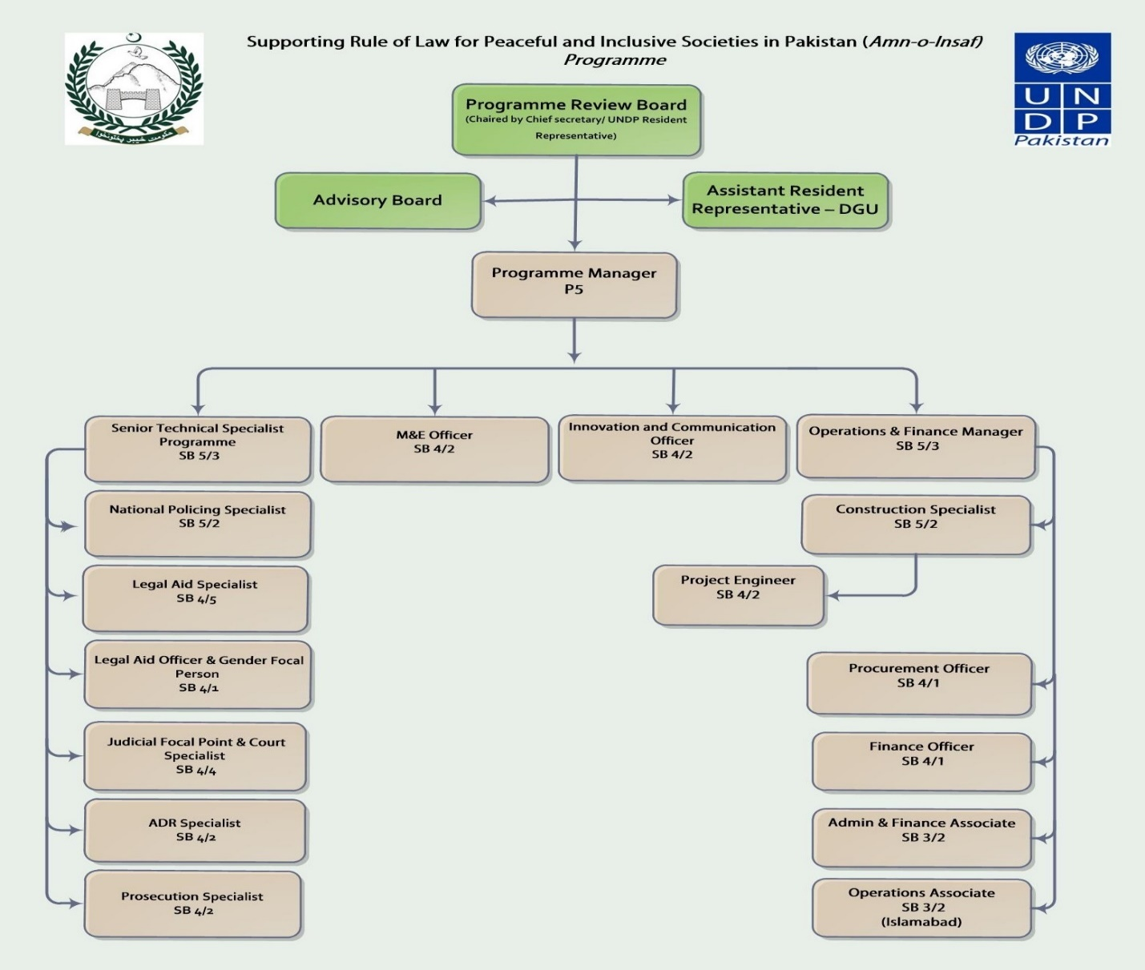

Monitoring And Evaluation
In accordance with UNDP’s programming policies and procedures, the project will be monitored through the following monitoring and evaluation plans for the entire 5 years of planning:

Monitoring Plan
Monitoring Activity | Purpose | Frequency | Expected Action | Cost  (if any)
Track results progress | Progress data against the results indicators in the LFA will be collected and analyzed to assess the progress of the project in achieving the agreed outputs. | Quarterly | Slower than expected progress will be addressed by project management. | N/A
Monitor and Manage Risk | Identify specific risks that may threaten achievement of intended results. Identify and monitor risk management actions using a risk log. This includes monitoring measures and plans that may have been required as per UNDP’s Social and Environmental Standards. Audits will be conducted in accordance with UNDP’s audit policy to manage financial risk. | Quarterly | Risks are identified by project management and actions are taken to manage risk. The risk log is actively maintained to keep track of identified risks and actions taken. | N/A
Learn | Knowledge, good practices and lessons will be captured regularly, as well as actively sourced from other projects and partners and integrated back into the project. | At least annually | Relevant lessons are captured by the project team and used to inform management decisions. | N/A
Annual Project Quality Assurance | The quality of the project will be assessed against UNDP’s quality standards to identify project strengths and weaknesses and to inform management decision making to improve the project. | Annually | Areas of strength and weakness will be reviewed by project management and used to inform decisions to improve project performance. | N/A
Review and Make Course Corrections | Internal review of data and evidence from all monitoring actions to inform decision making. | At least annually | Performance data, risks, lessons and quality will be discussed by the project board and used to make course corrections. | N/A
Project Report | A progress report will be presented to the Project Board and key stakeholders, consisting of progress data showing the results achieved against pre-defined annual targets at the output level, the annual project quality rating summary, an updated risk long with mitigation measures, and any evaluation or review reports prepared over the period. | Annually, and at the end of the project (final report) | Progress report detailing progress made against project indicators and activities as well as budget expenditure. | N/A
Final report to the donor | The final narrative report will be submitted to donors within 3 months of operational closure and the final financial report will be submitted within 12 months of operational closure. | Once, with 3 months of operational closure (12months for the financial report) | Final report detailing the results and impact of the project as well as the lessons learned and sustainability strategy. | N/A
Project Review (Project Board) | The project’s governance mechanism (i.e., project board) will hold regular project reviews to assess the performance of the project and review the Multi-Year Work Plan to ensure realistic budgeting over the life of the project. In the project’s final year, the Project Review Board shall hold an end-of-project review to capture lessons learned and discuss opportunities for scaling up and to socialize project results and lessons learned with relevant audiences. | Annual | Any quality concerns or slower than expected progress should be discussed by the project board and management actions agreed to address the issues identified. | N/A

- Evaluation Plan
Evaluation Title | Partners (if joint) | Related Strategic Plan Output | UNDAF/CPD Outcome | Planned Completion Date | Key Evaluation Stakeholders | Cost and Source of Funding
Mid-Term Evaluation | Firm/ NGO | Strengthened functioning, financing and institutional capacities facilitate access to justice and improve redress mechanisms by the rule of law institutions. | CPD Outcome 9:  Increased effectiveness and accountability of governance mechanisms | TBD | UNDP | US$70,000 (EU, UNDP, INL, USAID)
Training Impact Evaluation / Improve Service Delivery to the citizens | Firm/NGO | functioning, financing and institutional capacities facilitate access to justice and improve redress mechanisms by the rule of law institutions. | CPD Outcome 9:  Increased effectiveness and accountability of governance | TBD | UNDP | US$ 50,000 (EU, UNDP, INL, USAID)
Performance Evaluation of the Trainees | Firm/NGO | functioning, financing and institutional capacities facilitate access to justice and improve redress mechanisms by the rule of law institutions. | CPD Outcome 9:  Increased effectiveness and accountability of governance | TBD | UNDP | US$ 50,000 (EU, UNDP, INL, USAID)
Final Evaluation | Firm / NGOs | Strengthened functioning, financing and institutional capacities facilitate access to justice and improve redress mechanisms by the rule of law institutions. | CPD Outcome 9:  Increased effectiveness and accountability of governance | TBD | UNDP | US$ 100,000 (EU, UNDP, INL, USAID)

UNDP Annual Rule of Law Report 2017
2017 Sustainable Development Goals Report: https://unstats.un.org/sdgs/files/report/2017/TheSustainableDevelopmentGoalsReport2017.pdf
http://www.undp.org/content/undp/en/home/democratic-governance-and-peacebuilding/rule-of-law--justice--security-and-human-rights.html
UNDP Annual Rule of Law Report 2017, p.19
Rule of Law index 2017-2018 https://worldjusticeproject.org/our-work/wjp-rule-law-index/wjp-rule-law-index-2017%E2%80%932018
Law and Justice Commission of Pakistan report, http://www.ljcp.gov.pk/
Ibid, p.13
World Justice Project, General Population Poll 2013- 2017
Pakistan Bureau of Statistics http://www.pbs.gov.pk/sites/default/files//tables/Crimes%20Reported%20by%20Type%20and%20Provinces.pdf
Levies is a law enforcement agency operating in some districts of Khyber Pakhtunkhwa along with police and is the main force in the NMDs.
FCR was introduced in 1901 as a legal framework to indirectly administer FATA by the British
ICG. (2009).
Letter number Sp(J)HD/3-71/2019 of Home Department, dated 29th January 2019
CM okays over 900 judicial posts for merged districts, 10-2-2019, the Dawn, https://www.dawn.com/news/1462848
ibid
UNODC, Assessment of the Prosecution Services in Pakistan, 2010
‘Zia’s Islamization is most closely associated with the ‘Hudood’ laws. These are five presidential ordinances that introduced new sexual and property offenses, maintained the prohibition on the consumption of alcohol, and provided for exemplary Islamic punishments such as stoning to death (for adultery), whipping and amputation (for fornication and theft). These laws caused immense controversy and were criticized for being misogynistic and discriminatory towards religious minorities.’ P.6 http://pdf.usaid.gov/pdf_docs/PNADO130.pdf
http://www.humanrightsinitiative.org/download/1449728344rough-roads-to-equalitywomen-police-in-south-asia-august-2015.pdf
National Action Plan, 2014, https://nacta.gov.pk/nap-2014/
As set out in General Assembly resolution 66/290 of 10 September 2012 on follow-up to paragraph 143 on human security of the 2005 World Summit Outcome.
UNDP Pakistan Country Programme Document 2018-2022 (Outcome 1 (UNSDF Outcome 9): Support the primary rule of law institutions, including the police and criminal justice bodies to increase access to justice and legal aid. UNDP will also strengthen the federal and provincial institutional capacities for the effective implementation of governance mechanisms contributing to enhanced public service delivery.
Optional, if needed

